Social-Technical Network Effects in Open Source Software Communities: Understanding the Impacts of Dependency Networks on Project Success
Abstract
Purpose –The patterns in social dependency networks of online communities have been examined to be related to the success of an open source software (OSS) project. To better understand the OSS success, this study considers both social and technical dependencies from the network perspective.
Design/methodology/approach –This study investigates dependencies using three network metrics – centralization, betweenness, closeness – in developer and module networks. A longitudinal panel of projects hosted at Sourceforge.net is selected to test the impacts of the social and technical network effects on the technical success of OSS projects. Three models are used to analyze the social network effects in developer networks, the technical network effects in module networks and the social-technical network effects in both types of networks.
Findings – The results reveal nonlinear relationships between centralization in both social and technical networks and OSS success, highlighting the importance of a moderately centralized team structure and either highly decentralized or highly centralized software architecture.
Originality/value –This study is the first to consider the network metrics in both module networks of the technical sub-system and developer networks of the social sub-system to better understand their impacts on project success.
Keywords Open source software community, Dependency networks, Network effect, Social network analysis, Social-technical system

Introduction
Open source software (OSS) attracts many developers from dispersed geographical locations. Online communities make the distributed collaboration for developing OSS possible . OSS projects are typically developed in a decentralized fashion, and developers’ contribution is voluntary. However, with the increasing number of developers and code, the management of an OSS project will become more complicated. Developer communication networks, module networks and licensor networks have been investigated to understand organizational structure in an OSS community . OSS can be regarded as a socio-technical system to study the performance of software development .
As a social-technical system , an OSS project embodies both social (developers) and technical (modules) relationships. The social relationships are the connections that developers establish between each other when collaborating on software development. The technical relationships represent the linkages between software modules through function calls and public or utility functions as a result of shared developers. The social and technical relationships are intertwined when developers work on software modules in OSS development. Hence, a better understanding of OSS success should consider both social and technical dependencies from the network perspective .
Many researchers have theoretically and empirically studied the network effects of dependency networks in OSS development .To understand the success of an OSS project, social network analysis (SNA) has been used to examine patterns in social dependency networks . The connectedness and embeddedness of social networks have been found to influence project success , but few research studied the betweenness and closeness effects of the developer dependency network . Furthermore, previous research only studied either the developer or the module dependency network metrics but not both .
In this research, we measure the success of an OSS project through technical success, which relates to CVS commits that represent the level of technical functionality improvements an OSS project has achieved . Our empirical analysis is based on a large longitudinal panel dataset of projects hosted on Sourceforge.net, the largest Internet-based OSS development system in the world. Using SNA, we calculate three well-known network metrics – centralization, betweenness and closeness – and analyze the impacts of both social (developers) and technical (modules) network effects on the technical success of OSS projects. We consider the design of software modules and the organization of team members in a project as much more important for the purpose of understanding network impacts on project success . We further investigate social and technical network effects in developer and module networks, respectively. The networks studied in this research are dependency networks related to commit actions in the OSS . Our analysis focuses on the network level in predicting project success.
Our research has the following findings and contributions. First, our research contributes to the OSS literature by considering the impacts of both the social (developer) and technical (module) networks on OSS success. Our results show that, even though both the developer and module network measures can predict OSS project success when used separately, developer network measures are stronger predictors of OSS project success when both types of measures are considered simultaneously. Second, our research extends the literature on network effects in OSS development . Although some network metrics such as betweenness, closeness, and centralization have been used to explain project success, task accomplishment, and information quality , we are the first to consider these network metrics in both module networks of the technical sub-system and developer networks of the social sub-system to better understand their impacts on project success. Third, our findings offer insights on how OSS management can focus on developer and module network structural issues to enhance project success. It is particularly important for project leaders to monitor and control the centralization of team structure and software architecture in OSS development.

Theory and Hypotheses

Network effects and project success
Social network analysis (SNA) has been used to investigate the management of dependencies among various activities in an OSS community . From a social perspective, Temizkan and Kumar found that internal and external cohesions among developers have differential impacts on the success of patch-development (exploitation, implementation-oriented) and feature-request teams (exploration, innovation-oriented). From a technical standpoint, researchers have also studied technical dependency networks among software source code components . The design structure matrix (DSM) has been used to analyze the technical structure of the code . Moreover, the social and technical aspects of OSS development are intertwined because the collaboration of developers, designers, and testers may be governed by a technical task structure .
Due to the complex and dynamic nature of the OSS development process, it is difficult to have a good measure of the performance of OSS. Nevertheless, the performance of OSS can be understood using network effects and their impacts on the ultimate success of the OSS project . Prior research usually considers technical or commercial success of an information system . Since our goal is the success of an OSS project, what we focus on is the internal management of a project such as whether tasks including a few commits can be effectively completed. Therefore, in this paper, we focus on project-level outcomes and measure the success of an OSS through the technical success, which is the level of technical functionality improvements an OSS project has achieved .

OSS representation and network metrics
An OSS community is made up of different elements belonging to either the social or technical aspect. These elements interact with each other to form the dependency relationships in the system. The dependency relationships then intersect to become networks. Consequently the organization of an OSS can be represented using networks . Specifically, people and source code are the most fundamental elements in an OSS project. When developing an OSS, the usual action is “check out” and “check in” to commit source code to the CVS source code repository. The developer who commits code to make contributions is called a “committer,” and the component in the OSS that designates a specific source code functionally is called a “module.” We use developer networks and module networks to represent the social sub-system and the technical sub-system of OSS, respectively. In OSS development, it is important to consider both the social and the technical sub-systems because the relationships between developers and modules are intertwined. Two developers establish a connection with each other while collaborating on the same software modules, which forms social dependencies in OSS development. If two modules are modified by the same modification request, there will be technical dependencies between these two modules. This approach focuses on the measurement of logical dependencies in software development . In this study, to understand dependencies of a large number of projects in open source software, we use the representation of technical dependency through examining modification requests in CVS source code repository. As shown in Figure 1, the dependencies can be understood using the links in developer and module networks and be interpreted through network metrics.
[Insert Figure 1 here]
Network metrics are well-established and have been used to measure and understand various networks. In this study, we choose three network metrics (centralization, betweenness, and closeness) because they are the most widely used network metrics in SNA . These three network metrics are used to understand the impacts of networks on the success of an OSS project.

Effect of centralization
Centralization reflects the extent to which a network or group is organized around its focal node, and it is a measure of the cohesion of a group . Nodes with high degrees in a network are located in the “center” of this network and are “hubs” of information sharing and communication . In OSS development, usually there is no rigid organizational structures that control software development, and coordination is normally organized in a decentralized way . However, the decentralization of the development team may not be optimal because research showed that a hierarchy is an efficient way to control routine activities and innovation . Here, we use centralization as a measure of the hierarchical structure in an OSS community and examine how it may affect OSS project success. Figure 2(a) gives an example of centralization and shows that, from left to right, the centralization increases.
Among OSS projects, some OSS teams are highly centralized while most are not . In a centralized structure, the top layer of management has tight control over lower-level divisions. In a decentralized structure, the decision making power is distributed and the divisions may have different degrees of independence . Considering these reasons, a moderately centralized OSS project team is more efficient in information exchange and it has the ability to accomplish technical tasks smoothly. However, compared to moderated centralized organizations, an extremely high level of network centralization may result in the focal nodes being bottlenecks for information exchange because of the amount of information passing through them . Highly centralized networks may also represent uneven knowledge distribution such that knowledge concentrates in the focal nodes of the network, which does not benefit knowledge exchange or task accomplishment . That is, developer members in a project will benefit more in terms of task accomplishment under the control of moderately centralized commands, but a very highly centralized network may prevent efficient knowledge exchange and hinder task accomplishment. Based on the above arguments, we hypothesize a curvilinear relationship between the centralization of developer network and project success.
Hypothesis 1A (H1A): Compared with a very low or very high level of centralization, a moderate level of centralization in the developer network of a project will lead to a higher chance of project success.
In module networks, centralization is related to module similarity and task allocation. When centralization is very low, modules have more direct connections with each other and similarity among modules is high as no module serves as a hub for function calls in the network. As a result, the modules’ requirements on the developers’ knowledge and experience are similar, making the allocation of the right developers to the appropriate modules easier . This will lead to a higher chance of project success. When centralization in the module network increases to a moderate level, some become focal modules in the network with more function calls to other peripheral modules. The differentiation among the modules makes it more difficult to guarantee the right developers work on the right modules, especially when developers voluntarily commit to different modules. Hence the chance of project success is lower. As the centralization of the module network further increases to a very high level, two types of modules emerge in the network: a focal module that is located at the center of the network and the remaining peripheral modules that share connections with the focal module but not with each other. The focal module is likely a public or utility module containing frequently used functions . Because the overwhelming majority of modules in the network are peripheral ones and they are highly similar to each other from a network structure perspective, it is easy to match the right developers with the right modules, and the project is more likely to succeed . Based on the above arguments, we hypothesize a curvilinear relationship between the centralization of a module network and project success.
Hypothesis 1B (H1B): Compared with a moderate level of centralization, a very low or very high level of centralization in the module network of a project will lead to a higher chance of project success.

Effect of betweenness
In dependency networks, structural holes are gaps in information flows between actors linked to the same ego but not linked to each other . The actors on either side of the hole access different flows of information, and the ego who has high betweenness plays a key role in bridging the two sides of the hole . During OSS development, developers exchange information with each other to create useful code, and modules can also call each other to implement the designated functions. Betweenness, a measure of structural holes, represents the extent to which the ego of developers or modules exchanges non-redundant information coming from different parts of the network . High betweenness means there is more likely synergies among diverse ideas . Figure 2(b) gives an example of betweenness and shows that, from left to right, the betweenness of the focal node increases.
Conceptually, a node with high betweenness can be thought of as “bridges” or “boundary spanners” in a network . Developers with the role of “bridges” in developer networks are coordinators during collaboration to accomplish tasks . If between two developers with an indirect connection there is a shortcut for exchanging information through a coordinator, it is easier for them to communicate with each other. If in a project the number of developers who can play the role of coordinators is moderately high, these developers with high betweenness can bridge structural holes and obtain a variety of non-redundant information to promote effective communication, leading to a higher likelihood of project success . In contrast, when betweenness is low, there is a small number of developers who serve as such structural holes, and the exchange of non-redundant information will be less efficient. When the betweenness of developers in an OSS project is extremely high, the information load of developers that serve as such bridges will be very high and they may be overwhelmed with the need to bridge communication between other developers. This high betweenness will lead to decreased performance for the whole project team as knowledge sharing and information exchange becomes congested. Hence, the project is less likely to succeed. In summary, considering the need to balance non-redundant information exchange and information load among developers, we hypothesize a curvilinear relationship between the betweenness of a developer network and project success.
Hypothesis 2A (H2A): Compared with a very low or very high level of betweenness, a moderate level of betweenness in the developer network of a project will lead to a higher chance of project success.
In software development, “bridges” or “adapters” are design patterns that translate one interface for a class into a compatible interface . In a module network, modules with high betweenness serve as bridges and coordinate to avoid chaotic calls among these modules . Adapters help modules work together efficiently and can be developed more efficiently through the coordination between shared developers . When the betweenness of a module network is moderately high, there are more modules with high betweenness that can play the role of the adapters so that the corresponding functions can be called more efficiently during development , compared with the scenario when the betweenness is low. However, if the betweenness of a module network is very high, these adapters will have high information overload and their performance will deteriorate, leading to an inefficiency in the whole project . Therefore, a project with moderately high betweenness in the module network is more advantageous, considering the balance between development coordination and information load among modules. Based on the above discussions, we propose the following hypothesis:
Hypothesis 2B (H2B): Compared with a very low or very high level of betweenness, a moderate level of betweenness in the modules network of a project will lead to a higher chance of project success.

Effect of closeness
The closeness of dependency networks represents the ability that developers or modules obtain information from others through the shortest paths in a network . During interactions in the development of an OSS, when developers want to find help from others who work together inside a project, they may not be able to contact the target people directly because they do not have a direct link to them. An efficient way to build this relationship is to contact a mutual collaborator between the two . Similarly, a module may not be able to call a function of another module if the two are not directly connected. The question is how close the source and the target developers or modules are. In SNA, “closeness” measures how many steps are required to access every other node from a given node . Intuitively, closeness provides a metric of the extent to which a given node has short paths to all other nodes in the network. A node with a higher closeness is closer to all other nodes and has rapid access to all information . Figure 2(c) gives examples of closeness and shows that, from left to right, the closeness of the focal node increases.
When closeness is low in a developer network, developers do not depend much on others in task accomplishment partly because their needed information may be too far to be obtained , and the coupling between developers is low. When closeness increases, the interactions among developers become more cohesive and knowledge sharing among developers will strengthen . When the developers in a project interact more closely with each other, developers will depend on the team’s knowledge stored in the transactive memory system, a mechanism through which groups collectively encode, store, and retrieve knowledge . Therefore, the close interactions among developers will lead to more efficient knowledge sharing in OSS development. Based on the above arguments, we hypothesize a positive linear relationship between the closeness of a developer network and project success.
Hypothesis 3A (H3A): The closeness of developers in the developer network of a project has a positive relationship with project success.
In module networks, a closer relationship between modules means it takes fewer function calls to reach the target module from the originating one. As a result, operations in one module have a higher possibility in influencing operations in other modules in the network. This can be seen from the examples given in Figure 2(c). As average module closeness increases from the left to the right, connections between the modules increase at the network level and the network becomes more complicated. In OSS development, the increase of closeness in the module network will lead to tighter coupling between modules , making the software more difficult to maintain . As a result, we hypothesize a negative relationship between the closeness of a module network and project success.
Hypothesis 3B (H3B): The closeness of modules in the module network of a project has a negative relationship with project success.
[Insert Figure 2 here]

Methods

Data collection
To empirically test our hypotheses, we used a panel dataset collected from an OSS community. The dataset in this study was collected from Sourceforge.net using CVSAnalY (available at http://metricsgrimoire.github.io/CVSAnalY/), a software that extracts data from CVS subversion repository logs and saves the data into SQL databases. The “log” table in the MySQL database stored information on all the operations in the downloaded projects. This table had a total of 28,912,945 records belonging to 28,402 projects. Each record stored detailed information about one commit operation, such as commit time, committer id, project id, file id, module id, and file type.
We used the log data to construct the developer and module networks. In the analysis of a social network, even though the dyad of two nodes is the basic topology, the triad of three nodes makes the calculation of most network metrics meaningful . As a result, we were only interested in projects with at least three active developers or modules in a month. At the end, we obtained 118 projects with at least three active developers in a certain month, resulting in a total of 3123 monthly observations. We also obtained 88 projects with at least three active modules in a certain month, which resulting in 1738 monthly observations. After combining these two datasets, we obtained an integrated dataset of 87 projects with at least three active developers and modules in a certain month, resulting in 1621 monthly observations.

Dependency network construction
Based on the meta-matrix approach that considers all elements of an organization such as tasks, people, and skills as nodes in networks , developers and modules of OSS projects are considered nodes and dependency relationships are considered edges (links). For hypothesis testing, we built developer and module networks in this study. Therefore, we have:
Developer networks (developer to developer): each node corresponds to a particular developer. Two developers were linked when they both contributed to at least “one” common module. The weight of each edge in the developer network is the number of commit actions performed by both developers to all common modules during a particular time period.
Module networks (module to module): each node represents a software module of a project. Two modules were linked when there were at least “two” different modification actions from two developers applied to both modules. Edges were weighted by the total number of modification requests to both modules during a particular time period. We use a stricter definition requiring two shared modification requests to establish dependency between two modules. It is because, if two modules share only one modification request, they may have a high cognitive proximity . However, dependency would be stronger when at least two different modification requests apply to the same two modules. Hence, it is appropriate to apply the above method to build dependency networks for the management of dependency in this research. These networks were weighted and undirected networks. Figures 3 are examples.
[Insert Figure 3 here]

Measurement calculation

Dependent variables.
We used the monthly number of commits of a project in the CVS source code repository to represent the dependent variable . Generally, a larger number of commit actions means more functional improvement and better accomplishment of assigned tasks, which can be used to investigate technical success .

Independent variables.
We have network metrics as independent variables. Network measures for both developer and module networks – centralization, betweenness, closeness – are calculated using SNA in the R igraph environment .

Control variables.
First, we controlled for the average edge weights in a network, which was calculated as the mean value of the weights of all the edges in the network. In a developer network, the weight of an edge is equal to the total number of commits to the common modules committed by the developers at the two ends of this edge. In a module network, the weight of an edge is calculated to be the total number of commits by at least two common developers for the modules at the two ends of this edge. Second, the diameter, which is the length of the longest geodesic calculated by using a breadth-first search like method, was also included . Third, we also included project age (in months) to control for the time effect as projects become more mature . Fourth, network sizes both in developers and modules networks were controlled as well. To control for a potential curvilinear effect of network size on the dependent variables, we also incorporated squared network sizes into the models.
Table 1 reports the descriptive statistics of the independent and control variables for the combined sample of developer and module networks.
[Insert Table 1 here]

Model specification
We used Equations 1, 2, and 3 to evaluate such impacts and the mean of betweenness and closeness as global variables. Equation 1 is the model for social network effects in developer networks, Equation 2 is the model of technical network effects in module networks, and Equation 3 is the integrated model for social-technical network effects in both types of networks.
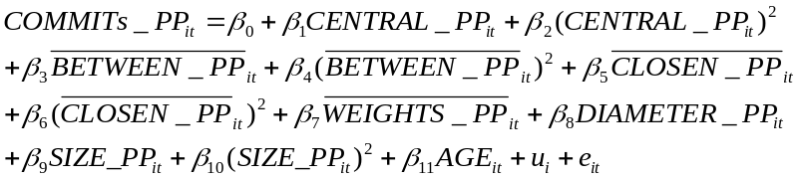 | (1)
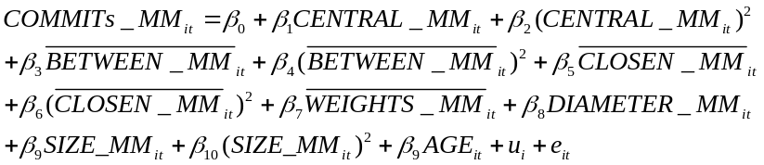 | (2)
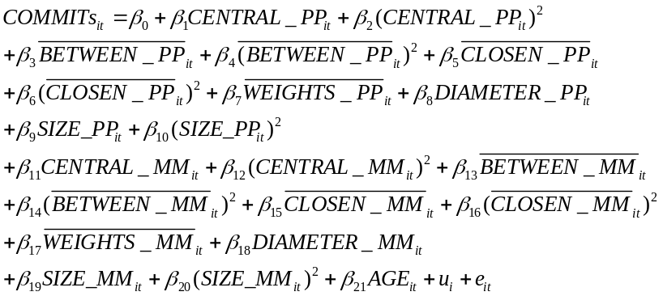 | (3)
Where i denotes the project; t denotes the month from 1999 to 2005; COMMITs_{it} is the dependent variables that represent the monthly commit numbers of Project i during Month t; COMMITs_PP_{it} and COMMITs_MM_{it} are the dependent variables that represent the monthly commit numbers of Project i during Month t related to the developer and module networks, respectively; CENTRAL_PP_{it} (CENTRAL_MM_{it}) , DIAMETER_PP_{it} (DIAMETER_MM_{it}) and SIZE_PP_{it} (SIZE_MM_{it}) represent the centralization, diameter and network size of the developer (module) network for Project i during Month t, respectively; 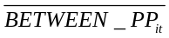, 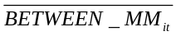, 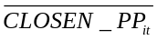, 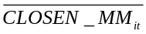, 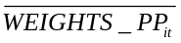, and 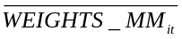 represent the average betweenness, closeness, weights of the developer (module) network for Project i during Month t, respectively;  is the corresponding project age in months for Project i during Month t; u_{i} is the fixed effect of Project i, and e_{it} is the panel error term.
The correlation coefficients between each pair of independent and control variables ranged from 0.001 to 0.618, revealing no high correlations. The variance inflation factor (VIF) values of all the first-order independent and control variables were lower than 10, indicating there are no multicollinearity issues . We also used the Wooldridge test to check for autocorrelation in the unbalanced panel data and found that the null hypothesis of no first order autocorrelation was weakly rejected. That is, there exists first order autocorrelation in the panel data. Therefore, it is inappropriate to use a linear regression on the panel data. Furthermore, because dependent variables were count data and fit negative binomial distribution, as shown in Figure 4, we estimated the models using random-effects and fixed-effects negative binomial regressions.
[Insert Figure 4 here]

Results
In the Hausman test , the null hypothesis that the preferred model is random-effects vs. the alternative the fixed-effects is rejected. Therefore, the fixed-effects model is more suitable in the regression than the random-effects models. Because of the large number of panels, estimation of the fixed-effects models was accomplished using a conditional maximum likelihood estimator where all time invariant individual effects i were conditioned out of the model using a project’s total count . Therefore, we used conditional fixed-effects negative binomial regression to test our hypotheses.

Hypotheses testing results
The results of network effects on project success are shown in Table 2. Models 1, 2, and 3 represent the hypothesis testing results using the developer networks only, module networks only, and both types of networks, respectively.
[Insert Table 2 here]
In developer networks, the coefficients of centralization were positive and significant (Model 1: β=0.259, p<0.01; Model 3: β=0.150, p<0.01), while the coefficients of centralization squared were negative and significant (Model 1: β=-0.113, p<0.01; Model 3: β=-0.077, p<0.01). The above results support H1A. The influence of developer network centralization ranging from 0 to 1 is drawn as the dash-dotted line in Figure 5, which illustrates this inverted U-shaped relationship. For developer position variables, the coefficients of 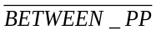 (Model 1: β=0.142, p<0.01; Model 3: β=0.195, p<0.01) were positive and significant, while the coefficients of squared (Model 1: β=-0.002, p<0.05; Model 3: β=-0.004, p<0.05) were negative and significant. Thus, these results support H2A. The coefficient of 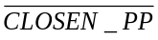 was positive and significant in Model 1 (β=0.211, p<0.01) but not in Model 3 (β=0.052, p>0.1). Similarly, the coefficient of squared was positive and significant in Model 1 (β=0.076, p<0.01) but not in Model 3 (β=0.017, p>0.1). Therefore, H3A was supported when we only considered the network effects of developer networks.
[Insert Figure 5 here]
In module networks, the coefficients of centralization (Model 2: β=-0.069, p<0.1; Model 3: β=-0.073, p<0.1) were negative and significant. The coefficients of centralization squared (Model 2: β=0.018, p<0.1; Model 3: β=0.027, p<0.05) were positive and significant. Hence, H1B was supported. The influence of module network centralization ranging from 0 to 1 is drawn as the solid line in Figure 5, which illustrates this U-shaped relationship. For module position variables, the coefficients of 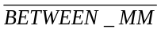 (Model 2: β=0.050, p>0.1; Model 3: β=0.036, p>0.1) and squared (Model 2: β=-0.003, p>0.1; Model 3: β=-0.0003, p>0.1) were not significant in either Model 2 or 3. Thus H2B was not supported. The coefficient of 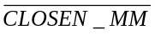 was positive and significant in Model 2 (β=0.135, p<0.01) but not in Model 3 (β=-0.030, p>0.1). The coefficient of squared was negative and significant in Model 2 (β=-0.039, p<0.01) but not in Model 3 (β=0.001, p>0.1). These results indicated an inverted U-shaped relationship between and project success when we considered the module network only. Therefore, H3B was not supported.

Discussions

Theoretical implications
This research has the following theoretical implications. On the one hand, we add to prior research on OSS success by investigating the impacts of social and technical structures. Although the social structure and technical structure have been studied separately, to the best of our knowledge, the current study is the first attempt in investigating a project’s success from both perspectives. Our results show that the impacts of social developer networks and technical module networks on project success are different. While most network metrics are significant when examined separately in either the developer or module networks, developer network-related metrics were shown to be more important predictors of project success when both types of network metrics are taken into consideration. Although technical system designs are usually copies of social communication designs , social subsystem is more important than technical subsystem as developers create the software modules.
On the other hand, our study also contributes to the research stream on network effects in OSS development from the social-technical network perspective . Three network metrics were used to examine the management of dependency in both module and developer networks. At the network level, the network effect of centralization in developer networks has an inverted U-shaped relationship with OSS success. It suggests that, to improve development, organizational structure of an OSS project should be moderately centralized. This finding is different from a previous research that shows a negative effect between centralization and work impact of an enterprise system , but consistent with another previous research that showed power control is needed to keep an organization more efficient in implementing tasks . In contrast, as the centralization of a module network increases, from the perspective of the network, the modules become more diverse and after reaching a moderate level of centralization the modules become more similar, resulting in a very low or very high level of centralization being more beneficial to the success of an OSS project.
Corroborating the results from previous research, we found that a moderate level of betweenness between developers leads to a higher chance of OSS project success. This is because nodes with higher betweenness are dedicated to bridging structural holes in organizations in order to promote coordination . However, we did not find evidence on the impact of betweenness in module networks on project success. As the betweenness of a module network increases, the capability of the modules to serve as adapters also increases, which will increase the numbers of function calls between the modules. At the same time, the increase in betweenness will lead to information overload among the modules and the developers working on these modules. These two effects may cancel each other out, resulting in the non-significant effect of module betweenness on project success.
A higher closeness in developer networks means more convenient access to help from other developers in an OSS project, which is consistent with the positive linear relationship revealed in previous research . The inverted U-shaped relationship between closeness and OSS success in module networks revealed in this research indicates that a moderate level of module closeness will be the best in achieving project success. When closeness in module networks is very high, there are more direct connections between the modules and the network is more complicated, which may lead to a higher difficulty in software maintenance. On the other hand, when closeness is low, modules do not share developers very much with each other and developers may not be able to easily take advantage of the functions and features in other modules.

Practical implications
Our findings offer insights on how OSS management can focus on developer and module network structural issues to enhance project success. First, OSS project leaders should pay attention to the structure of the developer team. Even though the technical artifact is the final product of an OSS project, the technical success of a project is driven more by the social structure. When an appropriate team structure is put in place, collaboration among the developers and task completion can be optimized, hence leading to appropriate software architecture and project success. Second, the developer community of an OSS should have a moderately centralized team structure. Although developers voluntarily work on an OSS project and typically join an OSS community in a decentralized fashion from different geographical locations , they still need instructions in order to make efficient contributions to the project. It is necessary to keep a centralized control, e.g., to have a core development management team, to improve the efficiency of task assignments and accomplishments. However, we also need to keep a decentralized team structure to promote knowledge sharing and innovation because of the voluntary participation of developers. Third, OSS project leaders should try to achieve a moderate level of betweenness in the developer network. This can be done by obtaining feedback from the developers. If some feel that they are too overwhelmed by serving as communication bridges for other developers, the relevant developers can be introduced to each other or recommended to collaborate on a module so that they can get acquainted with each other and avoid communicating through the focal developers.

Conclusions
In this study, we have examined developers and modules in an OSS community and utilized SNA to investigate the impacts of network effects on project success. Three well-established network metrics, i.e., centralization, betweenness, and closeness, were used to understand the management of dependencies in both developer and module networks. The hypotheses at the network level were tested by analyzing a longitudinal panel of projects hosted on Sourceforge.net to generate theoretical and practical implications. In summary, the most important contribution of this research lies in the examination of network effects in both developer and module networks to better understand the management of dependencies in OSS development.
Our research has the following limitations. First, we did not analyze on the dynamics of interactions in the social-technical system of OSS community. Second, in the network analysis, we did not consider weights of edges when calculating the network metrics. Future extensions to our research can address some of the above-mentioned limitations. The network analysis can also be extended to weighted dependency networks. Moreover, an agent-based computational model can be built to perform what-if analyses and observe the network effects during dependency network structural changes. Third, we only considered the technical success (i.e., number of commits) of an OSS project due to limitations in data availability. Future research can examine the commercial success as indicated by the number of downloads when such data are available.

References
Ahuja, M.K. and K.M. Carley (1999), “Network Structure in Virtual Organizations”, Organization Science, Vol. 10, No. 6, pp. 741-757.
Ahuja, M.K., D.F. Galletta and K.M. Carley (2003), “Individual centrality and performance in virtual R&D groups: An empirical study”, Management science, Vol. 49, No. 1, pp. 21-38.
Amrit, C. and J. van Hillegersberg (2008), “Detecting Coordination Problems in Collaborative Software Development Environments”, Information Systems Management, Vol. 25, No. 1, pp. 57-70.
Awazu, Y. and K.C. Desouza (2004), “Open knowledge management: Lessons from the open source revolution”, Journal of the American Society for Information Science and Technology, Vol. 55, No. 11, pp. 1016-1019.
Bostrom, R.P. and J.S. Heinen (1977), “MIS Problems and Failures: A Socio-Technical Perspective, Part I: The Causes”, MIS Quarterly, Vol. 1, No. 3, pp. 17-32.
Bozeman, B. and J. Pfeffer (1983), “Power in Organizations”, Journal of Policy Analysis and Management, Vol. 2, No. 3.
Burt, R.S. (1995). Structural Holes: The Social Structure of Competition, Harvard University Press.
Burt, R.S. (2000). “The network structure of social capital”, Research in Organizational Behavior, Vol. 22, pp. 345-423.
Carley, K.M., Ed. (2002). “Smart Agents and Organizations of the Future”, The Handbook of New Media. Vol. 12, pp. 206-220.
Cataldo, M., P.A. Wagstrom, J.D. Herbsleb and K.M. Carley (2006), “Identification of coordination requirements: implications for the Design of collaboration and awareness tools”, Proceedings of the 2006 20th anniversary conference on Computer supported cooperative work, Banff, Alberta, Canada, ACM.
Chatterjee, S., A.S. Hadi and B. Price (2000). Regression Analysis By Example. New York, John Wiley & Sons, INC.
Conaldi, G. and A. Lomi (2013), “The dual network structure of organizational problem solving: A case study on open source software development”, Social Networks, Vol. 35, No. 2, pp. 237-250.
Conway, M.E. (1968), “How Do Committees Invent?”, Datamation, Vol. 14, No. 5, pp. 28-31.
Coplien, J., D. Hoffman and D. Weiss (1998), “Commonality and variability in software engineering”, Software, IEEE, Vol. 15, No. 6, pp. 37-45.
Crowston, K. and J. Howison (2005), “The social structure of Free and Open Source software development”, First Monday, Vol. 10, No. 2.
Crowston, K. and J. Howison (2006), “Hierarchy and centralization in Free and Open Source Software team communications”, Knowledge, Technology and Policy, Vol. 18, No. 4, pp. 65-85.
DeLone, W.H. and E.R. McLean (1992), “Information Systems Success: The Quest for the Dependent Variable”, Information Systems Research, Vol. 3, No. 1, pp. 36-60.
Freeman, L.C. (1979), “Centrality in Social Networks I: Conceptual Clarification”, Social Networks, Vol. 1, No. 3, pp. 215-239.
Fulk, J. and G. DeSanctis (1995), “Electronic communication and changing organizational forms”, Organization science, Vol. 6, No. 4, pp. 337-349.
Gall, H., K. Hajek and M. Jazayeri (1998). Detection of logical coupling based on product release history. Proceedings. International Conference on Software Maintenance, IEEE, pp. 190-198.
Gamma, E., R. Helm, R. Johnson and J.M. Vlissides (1994). Design Patterns: Elements of Reusable Object-Oriented Software, Addison-Wesley Professional.
Gnyawali, D.R. and R. Madhavan (2001), “Cooperative networks and competitive dynamics: a structural embeddedness perspective”, The Academy of Management Review, Vol. 26, No. 3, pp. 431-445.
Grewal, R., G.L. Lilien and G. Mallapragada (2006), “Location, Location, Location: How Network Embeddedness Affects Project Success in Open Source Systems”, Management Science, Vol. 52, No. 7, pp. 1043-1056.
Gurnania, H. and Y. Gerchakb (2006), “Coordination in decentralized assembly systems with uncertain component yieldsstar”, European Journal of Operational Research, Vol. 176, No. 3, pp. 1559-1576
Hahn, J., J.Y. Moon and C. Zhang (2008), “Emergence of new project teams from open source software developer networks: Impact of prior collaboration ties”, Information Systems Research, Vol. 19, No. 3, pp. 369-391.
Herbsleb, J.D. (2007). “Global software engineering: The future of socio-technical coordination”, Future of Software Engineering (FOSE’07), IEEE, pp. 188-198.
Herbsleb, J.D., A. Mockus and J.A. Roberts (2006), “Collaboration in Software Engineering Projects: A Theory of Coordination”, Proceedings of the International Conference on Information System (ICIS 2006), p. 38.
Howison, J. and K. Crowston (2014), “Collaboration Through Open Superposition: A Theory of the Open Source Way”, MIS Quarterly, Vol. 38, No. 1, pp. 29-50.
Hunsen, C., J. Siegmund and S. Apel (2020), “On the fulfillment of coordination requirements in open-source software projects: An exploratory study”, Empirical Software Engineering, Vol. 25, No. 6, pp. 4379-4426.
Ibarra, H., M. Kilduff and W. Tsai (2005), “Zooming in and out: Connecting Individuals and Collectivities at the Frontiers of Organizational Network Research”, Organization Science, Vol. 16, No. 4, pp. 359-371.
Kilduff, M. (1990), “The interpersonal structure of decision making: A social comparison approach to organizational choice”, Organizational Behavior and Human Decision Processes, Vol. 47, No. 2, pp. 270-288.
Kirsch, L.J., D.-G. Ko and M.H. Haney (2010), “Investigating the antecedents of team-based clan control: Adding social capital as a predictor”, Organization Science, Vol. 21, No. 2, pp. 469-489.
Knoben, J. and L.A.G. Oerlemans (2006), “Proximity and inter-organizational collaboration: A literature review”, International Journal of Management Reviews, Vol. 8, No. 2, pp. 71-89.
MacCormack, A., J. Rusnak and C.Y. Baldwin (2006), “Exploring the Structure of Complex Software Designs: An Empirical Study of Open Source and Proprietary Code”, Management Science, Vol. 52, No. 7, pp. 1015-1030.
MacCormack, A., J. Rusnak and C.Y. Baldwin (2007), “The impact of component modularity on design evolution: Evidence from the software industry”, Harvard Business School Technology & Operations Mgt. Unit Research Paper, pp. 08-038.
McClean, K., D. Greer and A. Jurek-Loughry (2021), “Social network analysis of open source software: A review and categorisation”, Information and Software Technology, p. 106442.
Morgan, E.L. (2000), “The Cathedral & the Bazaar: Musings on Linux and Open Source by an Accidental Revolutionary”, Information Technology and Libraries, Vol. 19, No. 2, p. 105.
Namjoo, Choi, Kwan and Yi (2015), “Raising the general public's awareness and adoption of open source software through social Q&A interactions”, Online Information Review, Vol. 39, No. 1, pp. 119-139.
Nan, N. (2011), “Capturing Bottom-Up Information Technology Use Processes: A Complex Adaptive Systems Model”, MIS Quarterly, Vol. 35, No. 2, pp. 505-532.
Newman, M.E.J. (2010). Networks: An Introduction, Oxford University Press.
Podolny, J.M., E.S. Toby and M.T. Hannan (1996), “Networks, Knowledge, and Niches: Competition in the Worldwide Semiconductor Industry, 1984-1991”, The American Journal of Sociology, Vol. 102, No. 3, pp. 659-689.
Premkumar, G., K. Ramamurthy and C.S. Saunders (2005), “Information processing view of organizations: An exploratory examination of fit in the context of interorganizational relationships”, Journal of Management Information Systems, Vol. 22, No. 1, pp. 257-294.
Raymond, E.S. (2001). The Cathedral & the Bazaar: Musings on Linux and Open Source by an Accidental Revolutionary, O’Reilly Media.
Robinson, C. and R.E. Schumacker (2009), “Interaction effects: centering, variance inflation factor, and interpretation issues”, Multiple Linear Regression Viewpoints, Vol. 35, No. 1, pp. 6-11.
Sasidharan, S., R. Santhanam, D.J. Brass and V. Sambamurthy (2012), “The Effects of Social Network Structure on Enterprise Systems Success: A Longitudinal Multilevel Analysis”, Information Systems Research, Vol. 23, No. 3, pp. 658-678.
Singh, P.V., Y. Tan and V. Mookerjee (2011), “Network effects: The influence of structural capital on open source project success”, MIS Quarterly, Vol. No. pp. 813-829.
Sosa, M. (2008), “A structured approach to predicting and managing technical interactions in software development”, Research in Engineering Design, Vol. 19, No. 1, pp. 47-70.
Stewart, K.J. and S. Gosain (2006), “The impact of ideology on effectiveness in open source software development teams”, MIS Quarterly, Vol. No. pp. 291-314.
Sutanto, J., Q. Jiang and C.-H. Tan (2021), “The contingent role of interproject connectedness in cultivating open source software projects”, The Journal of Strategic Information Systems, Vol. 30, No. 1, p. 101598.
Tan, Y., V. Mookerjee and P. Singh (2007), “Social capital, structural holes and team composition: Collaborative networks of the open source software community”, Proceedings of International Conference of Information Systems ( ICIS 2007), p. 155.
Tang, T.Y., E. Fang and W.J. Qualls (2020), “More is not necessarily better: an absorptive capacity perspective on network effects in open source software development communities”, MIS Quarterly, Vol. 44, No. 4, pp. 1651-1678.
Teixeira, J., G. Robles and J.M. González-Barahona (2015), “Lessons learned from applying social network analysis on an industrial Free/Libre/Open Source Software ecosystem”, Journal of Internet Services and Applications, Vol. 6, No. 1, pp. 1-27.
Temizkan, O. and R.L. Kumar (2015), “Exploitation and Exploration Networks in Open Source Software Development: An Artifact-Level Analysis”, Journal of Management Information Systems, Vol. 32, No. 1, pp. 116-150.
Thomas, W.M. and C. Kevin (1994), “The Interdisciplinary Study of Coordination”, ACM Computing Surveys, Vol. 26, No. 1, pp. 87-119.
Von Krogh, G., S. Haefliger, S. Spaeth and M.W. Wallin (2012), “Carrots and Rainbows: Motivation and Social Practice in Open Source Software Development”, MIS Quarterly, Vol. 36, No. 2, pp.
Von Krogh, G. and E. von Hippel (2006), “The Promise of Research on Open Source Software”, Management Science, Vol. 52, No. 7, pp. 975-983.
Wang, J., M.Y. Hu and M. Shanker (2012), “Human agency, social networks, and FOSS project success”, Journal of Business Research, Vol. 65, No. 7, pp. 977-984.
Wang, J., K. Zhang, X. Sun, Y. Tan, Q. Wu and Q. Wu (2019), “Package Network Model: A Way to Capture Holistic Structural Features of Open-Source Operating Systems”, Symmetry, Vol. 11, No. 2, p. 172.
Wasserman, S. and K. Faust (1994). Social Network Analysis: Methods and Applications, Cambridge, Cambridge University Press.
Wegner, D.M., T. Giuliano and P. Hertel, Eds. (1985). Cognitive interdependence in close relationships. Compatible and incompatible relationships. New York, Springer-Verlag.
Wooldridge, J.M. (2010). Econometric analysis of cross section and panel data, MIT press.
Yang, X., X. Li, D. Hu and H.J. Wang (2021), “Differential impacts of social influence on initial and sustained participation in open source software projects”, Journal of the Association for Information Science and Technology, Vol. 72, No. 9, pp. 1133-1147.

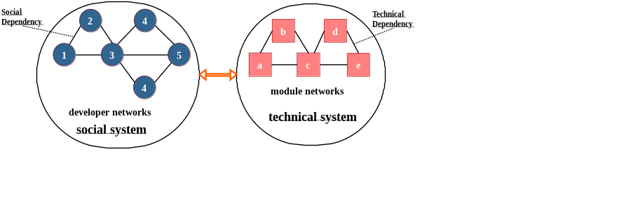
Figure 1. The management of dependency in a social-technical system of OSS community (On the left is a social system, and circles represent developers that communicate with each other to form developer networks. On the rightmost is a technical system, and squares represent modules that depend on each other to form module networks.)

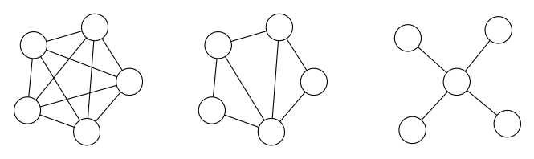
(a) The centralization of a network (From left to right, centralization increases.)

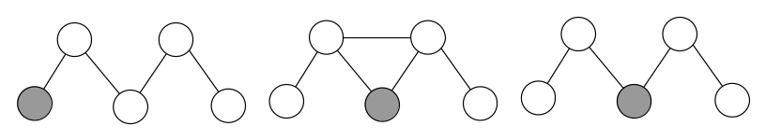
(b) The betweenness of the focal node in a network (From left to right, the betweenness of the focal (grey) node increases.)

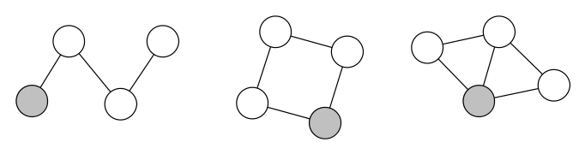
(c) The closeness of the focal node in a network (From left to right, the closeness of the focal (grey) node increases.)
Figure 2. Examples of centralization, betweenness and closeness in networks
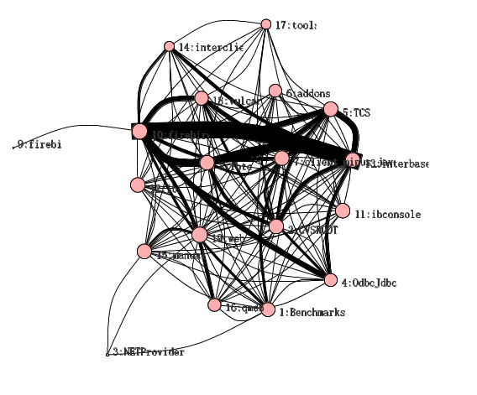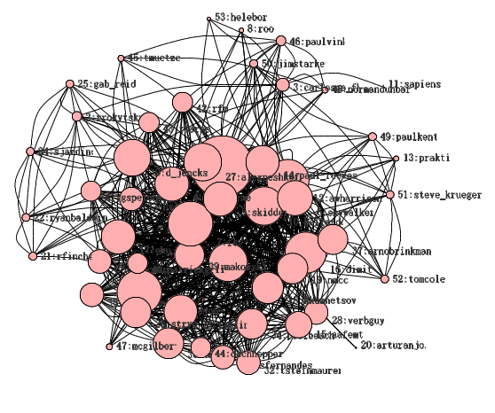
Figure 3. Examples of dependency networks of modules (left) and developers (right)
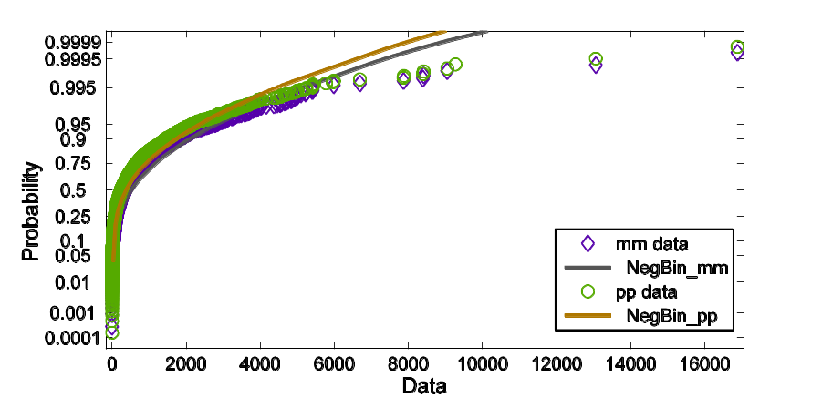
Figure 4. Fitting the developer and module networks with negative binomial distributions

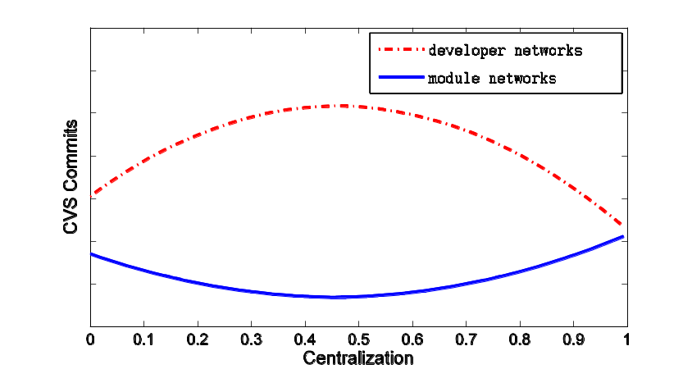
Figure 5. The impacts of centralization on CVS commits
Table 1. Descriptive statistics (N=1621)
Variable | Mean | Std. Dev. | Min | Max
 | 10.064 | 0.237 | 0 | 1
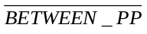 | 0.0177 | 0.049 | 0 | 1
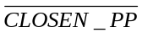 | 0.792 | 0.249 | 0.026 | 1
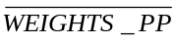 | 0.793 | 1.289 | 1.002 | 11.333
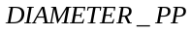 | 1.729 | 0.754 | 1 | 7
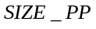 | 10.064 | 9.238 | 3 | 72
 | 0.297 | 0.158 | 0 | 1
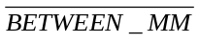 | 0.044 | 0.075
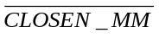 | 0.252 | 0.211 | 0.01 | 1
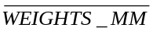 | 2.499 | 0.715 | 2 | 8.6
 | 1.607 | 0.626 | 1 | 5
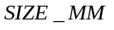 | 12.047 | 10.838 | 3 | 95
 | 55.609 | 15.951 | 9 | 83
Table 2. Results of network effects on project success using negative binomial regressions
Independent Variable |  | Model 1 |  | Model 2 |  | Model 3
 |  | Coef. | Std. Error | Coef. | Std. Error | Coef. | Std. Error
Developer Network Variables
Global Network  Variables |  | 0.259*** | 0.053 |  |  | 0.150*** | 0.059
Global Network  Variables | 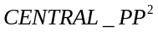 | -0.113*** | 0.021 |  |  | -0.077*** | 0.022
Developer Position Variables | 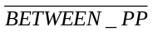 | 0.142*** | 0.032 |  |  | 0.195*** | 0.059
Developer Position Variables | 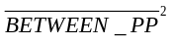 | -0.002** | 0.001 |  |  | -0.004** | 0.002
Developer Position Variables | 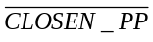 | 0.211*** | 0.054 |  |  | 0.052 | 0.067
Developer Position Variables | 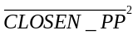 | 0.076*** | 0.030 |  |  | 0.017 | 0.034
Control Variables | 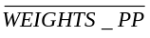 | 0.168*** | 0.015 |  |  | 0.131*** | 0.030
Control Variables | 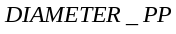 | -0.019 | 0.027 |  |  | -0.062* | 0.037
Control Variables | 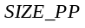 | 0.677*** | 0.032 |  |  | 0.578*** | 0.073
Control Variables | 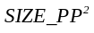 | -0.076*** | 0.006 |  |  | -0.076*** | 0.014
Module Network Variables
Global Network  Variables |  |  |  | -0.069* | 0.042 | -0.073* | 0.042
Global Network  Variables | 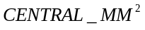 |  |  | 0.018* | 0.014 | 0.027** | 0.014
Module Position Variables | 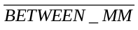 |  |  | 0.050 | 0.045 | 0.036 | 0.042
Module Position Variables | 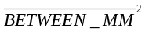 |  |  | -0.003 | 0.005 | -0.0003 | 0.005
Module Position Variables | 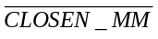 |  |  | 0.135*** | 0.046 | -0.030 | 0.055
Module Position Variables | 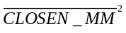 |  |  | -0.039*** | 0.017 | 0.001 | 0.018
Control Variables | 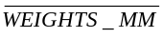 |  |  | 0.212*** | 0.019 | 0.044 | 0.030
Control Variables | 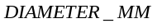 |  |  | 0.064 | 0.026 | -0.009 | 0.025
Control Variables | 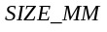 |  |  | 0.327*** | 0.061 | 0.034 | 0.080
Control Variables | 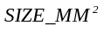 |  |  | -0.022*** | 0.008 | -0.005 | 0.013
Control Variable |  | -0.080*** | 0.016 | -0.060*** | 0.023 | -0.083*** | 0.023
CONSTANT |  | 0.205*** | 0.035 | 0.345*** | 0.039 | 0.546*** | 0.050
Log likelihood |  | -20125.174 |  | -11566.334 |  | -10733.431
No. of observations |  | 3123 |  | 1738 |  | 1621
No. of projects |  | 118 |  | 88 |  | 87
Notes: ***p≤0.01, **p≤ 0.05, * p≤ 0.1.

igraph is a free software package for manipulating graphs and is available at http://cneurocvs.rmki.kfki.hu/igraph/.

